附件八、全英語授課教學共進計畫-專業英語ESP教材格式

ESP教材格式說明：
1.教材內容的字體請統一使用Arial，僅各段落的說明文字請使用Times New Roman，以便區別。標題或重點可標示粗體，內文的文字大小請使用12pt。
2.各段落標題，例如Warm-up Activity、Reading、Listening、Speaking Activity、Writing等，文字大小請使用20pt。老師可自行新增/修改段落標題名稱，如P4範例黃底文字所示。[Topic]、[Description]等字樣僅作為提醒用無需保留，編輯時敬請刪除，謝謝。
3. ESP教材的1個完整單元，以具備單元主題(Topic)與上述提及的段落標題為原則，即Warm-up Activity、Reading、Listening、Speaking Activity、Writing…等內容。請以本校6大學院：機電、電資、工程、管理、設計、人社的專業領域知識，制訂單元主題。建議參考合作教師的EMI課程或這學期開設的專業英語ESP課程。
4.各段落標題底下的內容，可依老師設計的主題、使用的素材等，自行新增/刪除範例格式中的表格。(然，為有利老師排版，建議可參考範例格式中的各活動題型去設計喔!)
5.如有補充資料，例如聽力活動的文稿、延伸閱讀資源、各活動的答案等，請新增Appendix的段落，並標示Lesson #、該段落名稱等資訊。
6.完成的專業英語(ESP)教材檔案，檔案名稱請標示為「ESP教材-○○學院-Topic-教師中文姓名」，並儲存為Word檔案，以利雙語中心彙整，謝謝。
7.請避免重複使用本校原有的「北科之英」教材主題，如下表格：

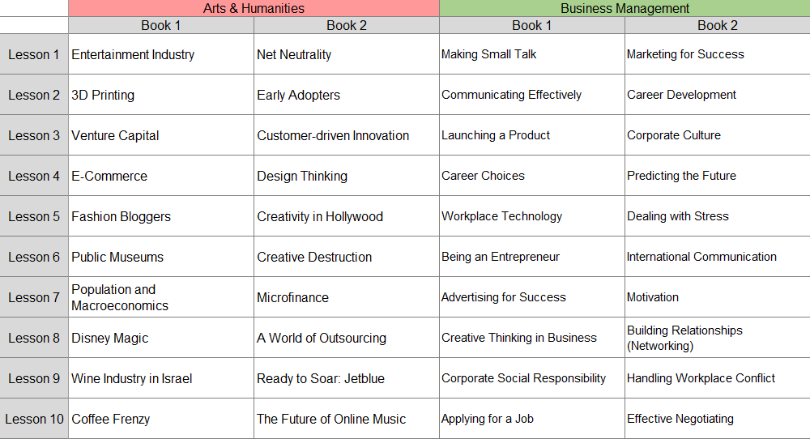
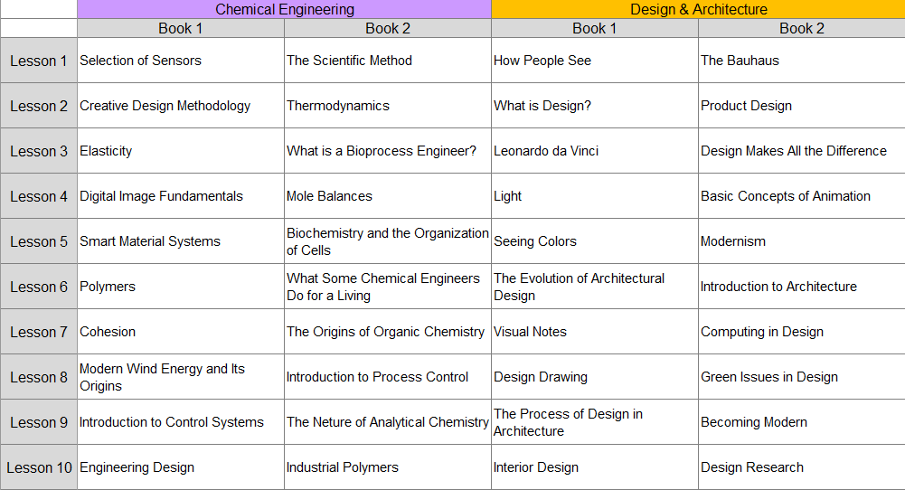
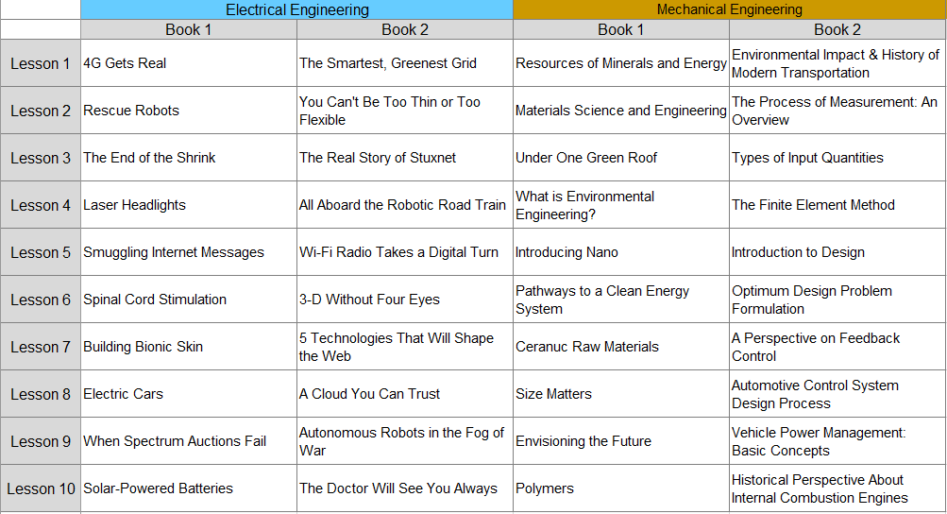

▲敬請刪除上述教材格式說明的頁面(P1~3)，並回傳您完成的1個完整單元ESP教材內容(Word檔案)至計畫窗口，謝謝。

LESSON
#
[Topic] Making Small Talk

Warm-up Activity 1
[Description] Work with a partner and ask each other the following questions:

- When have you had conversations in your language with people you did not know very well? (Examples: in a train or airplane/at a wedding or party/on the first day of a new semester at school/waiting in line at a concert, etc.)

- What did you talk about in those situations? How did the conversation begin?

- What do you like to talk about with people you don’t know very well? What topics do you not want to discuss in those situations?

Compare your answers and create a list of good topics to talk about with people you don’t know well, and another list with topics that are not good subjects for conversation with strangers or new friends.

Suitable Topics | Unsuitable Topics

Reading
[Description] Read the article below on making small talk in English. Then answer the comprehension questions.

[Topic] Making Small Talk in English

The ability to make ‘small talk’ is extremely valuable. Small talk gets friendships started and also helps build relationships before important business meetings and other events.

Why is small talk difficult for some English learners?

First of all, making small talk is not only a challenge for people learning English. It is also difficult for many native speakers. However, small talk can be especially challenging for some learners because making small talk means talking about almost anything – and that means having a wide vocabulary that can cover many topics.

How to Improve Small Talk Skills

If small talk seems difficult, then fear not! Here are some tips to improve your small talk skills. Keeping these tips in mind should improve your skills.

- Do some research
Spend time on the Internet, reading magazines, or watching TV programs about the type of people you are going to meet. For example: If you are taking a class with students from other countries, take time after the first few days of class to do some research into their countries and cultures. They will appreciate your interest and your conversations will be much more interesting.

- Use the Internet to gain specific vocabulary
This is related to doing research. If you have a business meeting, or are meeting people who share a common interest (e.g. a basketball team, a particular type of movie or food, etc.), take advantage of the Internet to learn specific vocabulary about that topic.

- Ask yourself about your own culture and conversation topics in your own language
Take time to make a list of common interests that are discussed when making small talk in your own culture. You can create the list in your own language, but check to make sure that you have the appropriate English vocabulary to make small talk on those topics.

- Find common interests
Once you find a subject that interests both of you, talk about it! You can do this in a number of ways: discussing travel, talking about the school or a friend you have in common, conversing about the differences between your culture and another culture (just be careful to make comparisons, rather than judgments, such as: “The food in my country is much better than the food here in England.”).

- Listen
Listening carefully will not only help you understand the person speaking to you, it will also encourage them to communicate better. You might be nervous and want to speak quickly, but being patient and letting others state their opinions will improve the quality of the discussion – and give you time to think of an answer!

- Stay away from religion/strong political beliefs
While you may believe in something very strongly, beginning conversations and making small talk about your own personal convictions may make the other person feel uncomfortable. Keep it light, and don’t try to convince the other person that you have the ‘right’ answer about a political system, cultural practice, or any other belief system.

Here is a list of appropriate small talk subjects. If you have difficulties speaking about any of these topics, try to improve your vocabulary by using the resources available to you (i.e. the internet, magazines, books, etc.).

- Sports – current matches or games, favorite teams, etc.
- Hobbies – free time activities are always interesting topics
- Weather – may sometimes be boring, but it can be a good way to start a conversation
- Family – general questions, not questions about private matters
- Media – films, books, magazines, etc.
- Holidays – where, when, etc. but NOT how much money it cost!
- Hometown – where do you come from, how is it different/similar to where you are now
- Job – general questions that are not too specific are best
- Fashion – latest trends that are popular now
- Celebrities – gossip can be fun, but it’s better to stay positive.

Here is a list of topics that are usually inappropriate for small talk with people you don’t know well:

- Salary – How much money do you earn? – “That’s none of your business!”
- Politics – This topic can lead to disagreement and conflict
- Intimate relationships – Suitable only for you and your partner – or maybe your best friend
- Religion – Be tolerant! Don’t say negative things about any religious topic
- Death – We all need to deal with it, but not the first time we meet someone new
- Financial – Most people prefer to keep financial information private
- Sales – Don’t try to sell something to someone you have just met.

Reading adapted from: “Making Small Talk”, Kenneth Beare, http://esl.about.com/od/speakingenglish/a/smalltalk.htm

Comprehension Questions

- According to the article, why do many English learners find it difficult to participate in small talk?

- Why is it a good idea to do research to improve your small talk skills?

- Why does the author think that it is a good idea to make a list of small talk subjects in your own language?

- Why is it important to be patient and listen to your conversation partner when making small talk?

- Why do you think it is not a good idea to ask someone how much money they spent on their vacation?

- Do you agree that celebrity gossip is a good small talk topic? Why or why not?

Vocabulary 1: Match
[Description] Match the words from the article on the left with the definitions on the right:

- ( ) challenging | - an evaluation of similarities and differences
- ( ) appropriate | - something that someone strongly believes is true
- ( ) cultures | - very personal and close to someone
- ( ) conviction | - things that are popular with many people
- ( ) comparison | - ways of life for different groups of people
- ( ) judgment | - being able to accept something you may not agree with
- ( ) trends | - suitable for a particular situation
- ( ) inappropriate | - difficult/hard to achieve
- ( ) intimate | - something not acceptable for a particular situation
- ( ) tolerant | - careful thought that often results in a decision

Vocabulary 2: Sentences
[Description] Choose from the words in Vocabulary Exercise 1 to complete the sentences below.

- The financial planner had a strong that the price of gold would rise significantly.
- Only her closest and most friends and family members knew that she was engaged to get married.
- There is no between the salary of a famous baseball player and the income of a normal factory worker.
- The marketing team followed the latest very carefully to anticipate what new products would be popular in the future.
- There are a number of diverse to be found on the Asian continent.
- She has an excellent fashion sense. She always wears the clothing to every event she attends.
- The Sales Manager is in trouble because he made comments to the wife of his boss.
- The investor displayed very poor in purchasing land in an area that suffers flooding every typhoon season.
- The Ironman Triathlon is one of the most endurance events she had ever participated in.
- The monks at the Buddhist temple were some of the kindest and most people the travelers met during their trip to Taiwan.

Vocabulary 3: Collocations
[Description] The nouns in the box below are found in the article. Match those nouns with the most appropriate groups of verbs to make strong collocations.

Nouns
challenges | information | conversation | resources | topics
cultures | judgments | discussion | relationships | skills

VERBS | NOUN
- casual/informative/dinner  - sensitive/interesting/diverse  - ancient/Asian/diverse  - close/family/business  - difficult/financial/environmental  - necessary/job/advanced  - thorough/interesting/intense  - personal/financial/legal  - natural/financial/company  - necessary/adequate/timely | ________________________________________  ________________________________________  ________________________________________  ________________________________________  ________________________________________  ________________________________________  ________________________________________  ________________________________________  ________________________________________  ________________________________________
Listening Activity
[Description] Listen to the talk. Number these questions in the order they are answered in the talk:
____ Who do we make small talk with?
____ Why do we need to master the skills of small talk?
____ When do we use small talk?
____ What is small talk?

[Description] Listen to the talk again and complete the summary about small talk.
Small talk is _______________ dialogue and different from _______________. Small talk typically occurs with someone you’ve just met or _________________________. We use small talk in situations where we want to _________________________ and develop rapport with them.

Adapted from: “Top 5 Best And Worst Small Talk Topics”, Laura Janzen,
https://www.torontospeechtherapy.com/blog/2020/best-and-worst-small-talk

Speaking Activity 1: Role Play
[Description] In groups of two, have conversations based on the appropriate small talk topics found in the Reading. Change groups after the first situation so every student can practice in both situations.

Situation 1: A and B are sitting next to each other on an airplane. A is going to Tokyo on a business trip. B will change planes in Tokyo and travel to Los Angeles to visit members of his family who live there.

Situation 2: A is a recent graduate and a new employee at Atlas Engineering Company. B has worked at Atlas for one year. They meet in the break area.

Speaking Activity 2
[Description] In your group, make a list of five small talk topics to discuss with someone you just met. Take turns reading your list to your partners and explain why you think that each topic would be appropriate and interesting to discuss with someone you don’t know well.

Example:
“I would like to make small talk about sports because I like many kinds of sports and I watch them on TV almost every day.” or “I like to talk about the weather to people I don’t know very well. The weather is a topic that everyone knows about and we all share the same experience.”

Writing: Thank you note
[Description] Imagine that last month you attended a “Job Interview Skills” seminar. This week you had an interview for a job at a hot new technology start-up company – and they hired you the very next day! Now write a thank-you email to the trainer of the seminar for the valuable tips you learned in the seminar. Be sure to mention the following points in your email:

- The job interview role-play practice at the seminar was very helpful in your actual job interview. You were prepared to answer the questions that the interviewer asked you.
- Mention that you used some of the tips that you learned at the seminar, including:
- You did a lot of research about the company that hired you.
- You were able to explain why your skills and experience made you a good match for that company.
- You arrived early for your interview.
- Your interview clothing was neat and tidy. You looked great!

To: John Harrison, Business Communication Partners
From:
Subject: Successful job interview

Dear John,

First of all, I would like to thank you for…

The interview role play practice was especially helpful because…

I was also able to use other tips that you taught me. For example, …

Finally,

Your sincerely,

_________________________

Appendix

Lesson #, Listening Activity
Answer key:
__3__ Who do we make small talk with?
__1__ Why do we need to master the skills of small talk?
__4__ When do we use small talk?
__2__ What is small talk?

Small talk is friendly, casual dialogue and different from in-depth conversations.
Small talk typically occurs with someone you've just met or don't know very well.
We use small talk in situations where we want to make the other person comfortable and develop rapport with them.

Transcript:
Many people feel uncomfortable when faced with a situation that requires them to engage in small talk. However, this type of interaction pops up in our daily lives all the time. Whether you are getting your hair done, catching up with co-workers or networking at a social event, the ability to hold a comfortable casual dialogue is a critical skill to possess. We’ve all experienced the awkward interactions and painfully long silences that occur when small talk goes wrong. So how can you master the art of chit chat and feel confident entering your next casual conversation? First, let’s begin by exploring what exactly is small talk. Small talk is friendly, casual dialogue about light, easy, relatable topics. This type of interaction is typically quite short and does not dive in to deep subjects or personal matters. Small talk is different from in-depth conversations which have a purpose and a direction. Second, you can make small talk with anyone, but it typically occurs with someone you've just met or don't know very well. Other potential small talk partners could include co-workers, customers/clients, superiors and/or subordinates at your workplace. Then, we use small talk in situations where we want to make the other person comfortable and develop rapport with them, but where in-depth and personal conversations would be inappropriate….

Adapted from: “Top 5 Best And Worst Small Talk Topics”, Laura Janzen,
https://www.torontospeechtherapy.com/blog/2020/best-and-worst-small-talk

